[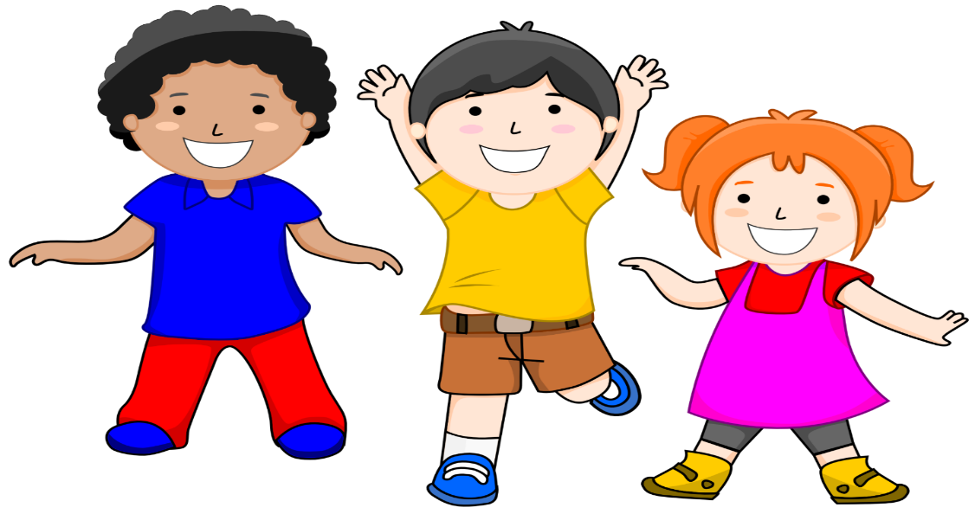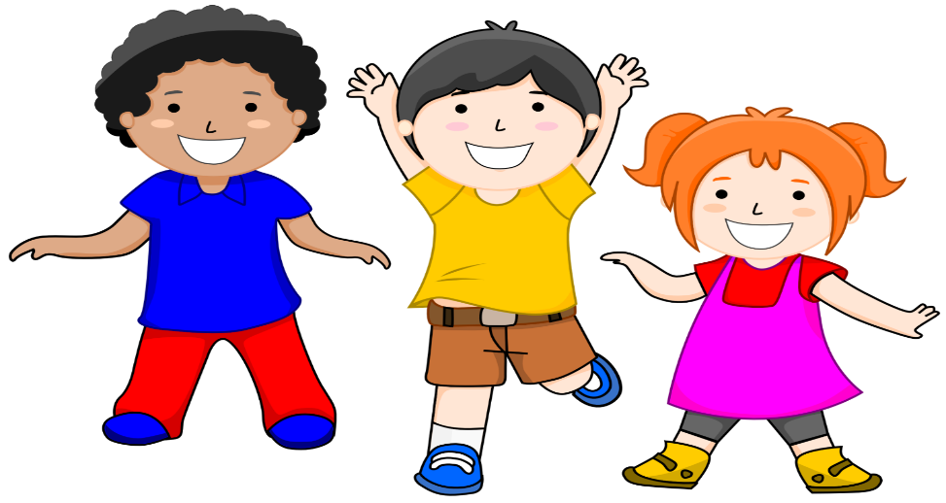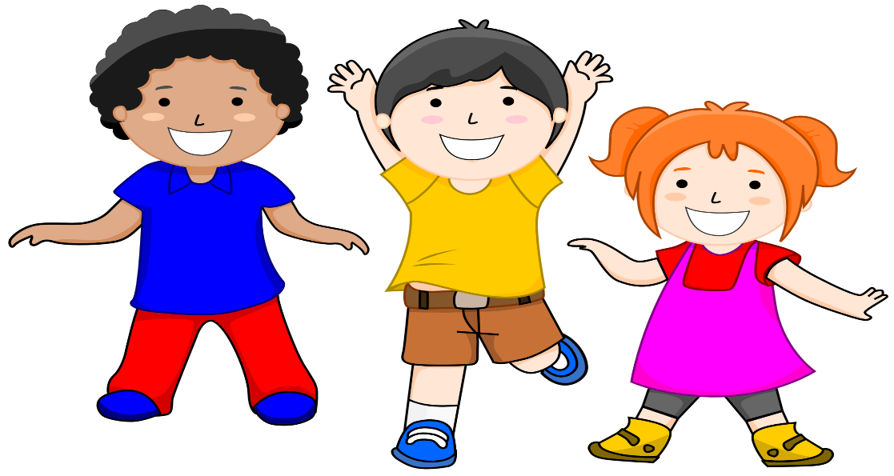](https://www.google.com/url?sa=i&url=https://webstockreview.net/explore/clipart-kid-background/&psig=AOvVaw14HYCsRRakx6NRBXKqfEiw&ust=1592064294275000&source=images&cd=vfe&ved=0CAIQjRxqFwoTCNCrmPHT_OkCFQAAAAAdAAAAABAd)[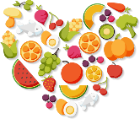](https://www.google.com/url?sa=i&url=http://clipart-library.com/clip-art/food-clipart-transparent-12.htm&psig=AOvVaw0ffmtpdtgknYIP-eKue2a7&ust=1592066139072000&source=images&cd=vfe&ved=0CAIQjRxqFwoTCPCatNja_OkCFQAAAAAdAAAAABAD)

**\*Don’t forget to send in all your videos and photographs! We can’t wait to see them!! ☺**

***Mindfulness***

Enjoy being creative with mindfulness colouring sheets.

Make something using dough, clay, pastry or recyclable materials.

Learn a new song

Find something that makes you laugh.

***Movement***

How many star jumps can you do in 30secs? Send in your videos! Can you do even more next time?

Learn a new dance and maybe record yourself

Help with a physical chore: sweeping up leaves, brushing the floor or vacuum cleaning!

**Keep moving!!**

Will you be able to complete all the challenges??

Get all your family involved!

***WELLNESS WEEK 2***

***JUNE 2020***

***Diet***

Design your own healthy eating plate/ poster.

Make a healthy smoothie

Try and eat 5 portions of fruit and veg each day