My three best memories of P.7

Confirmation:
We were so lucky to have our Confirmation just before lockdown. The thing I loved was seeing all my friends and family and I have lots of photographs of this amazing occasion.

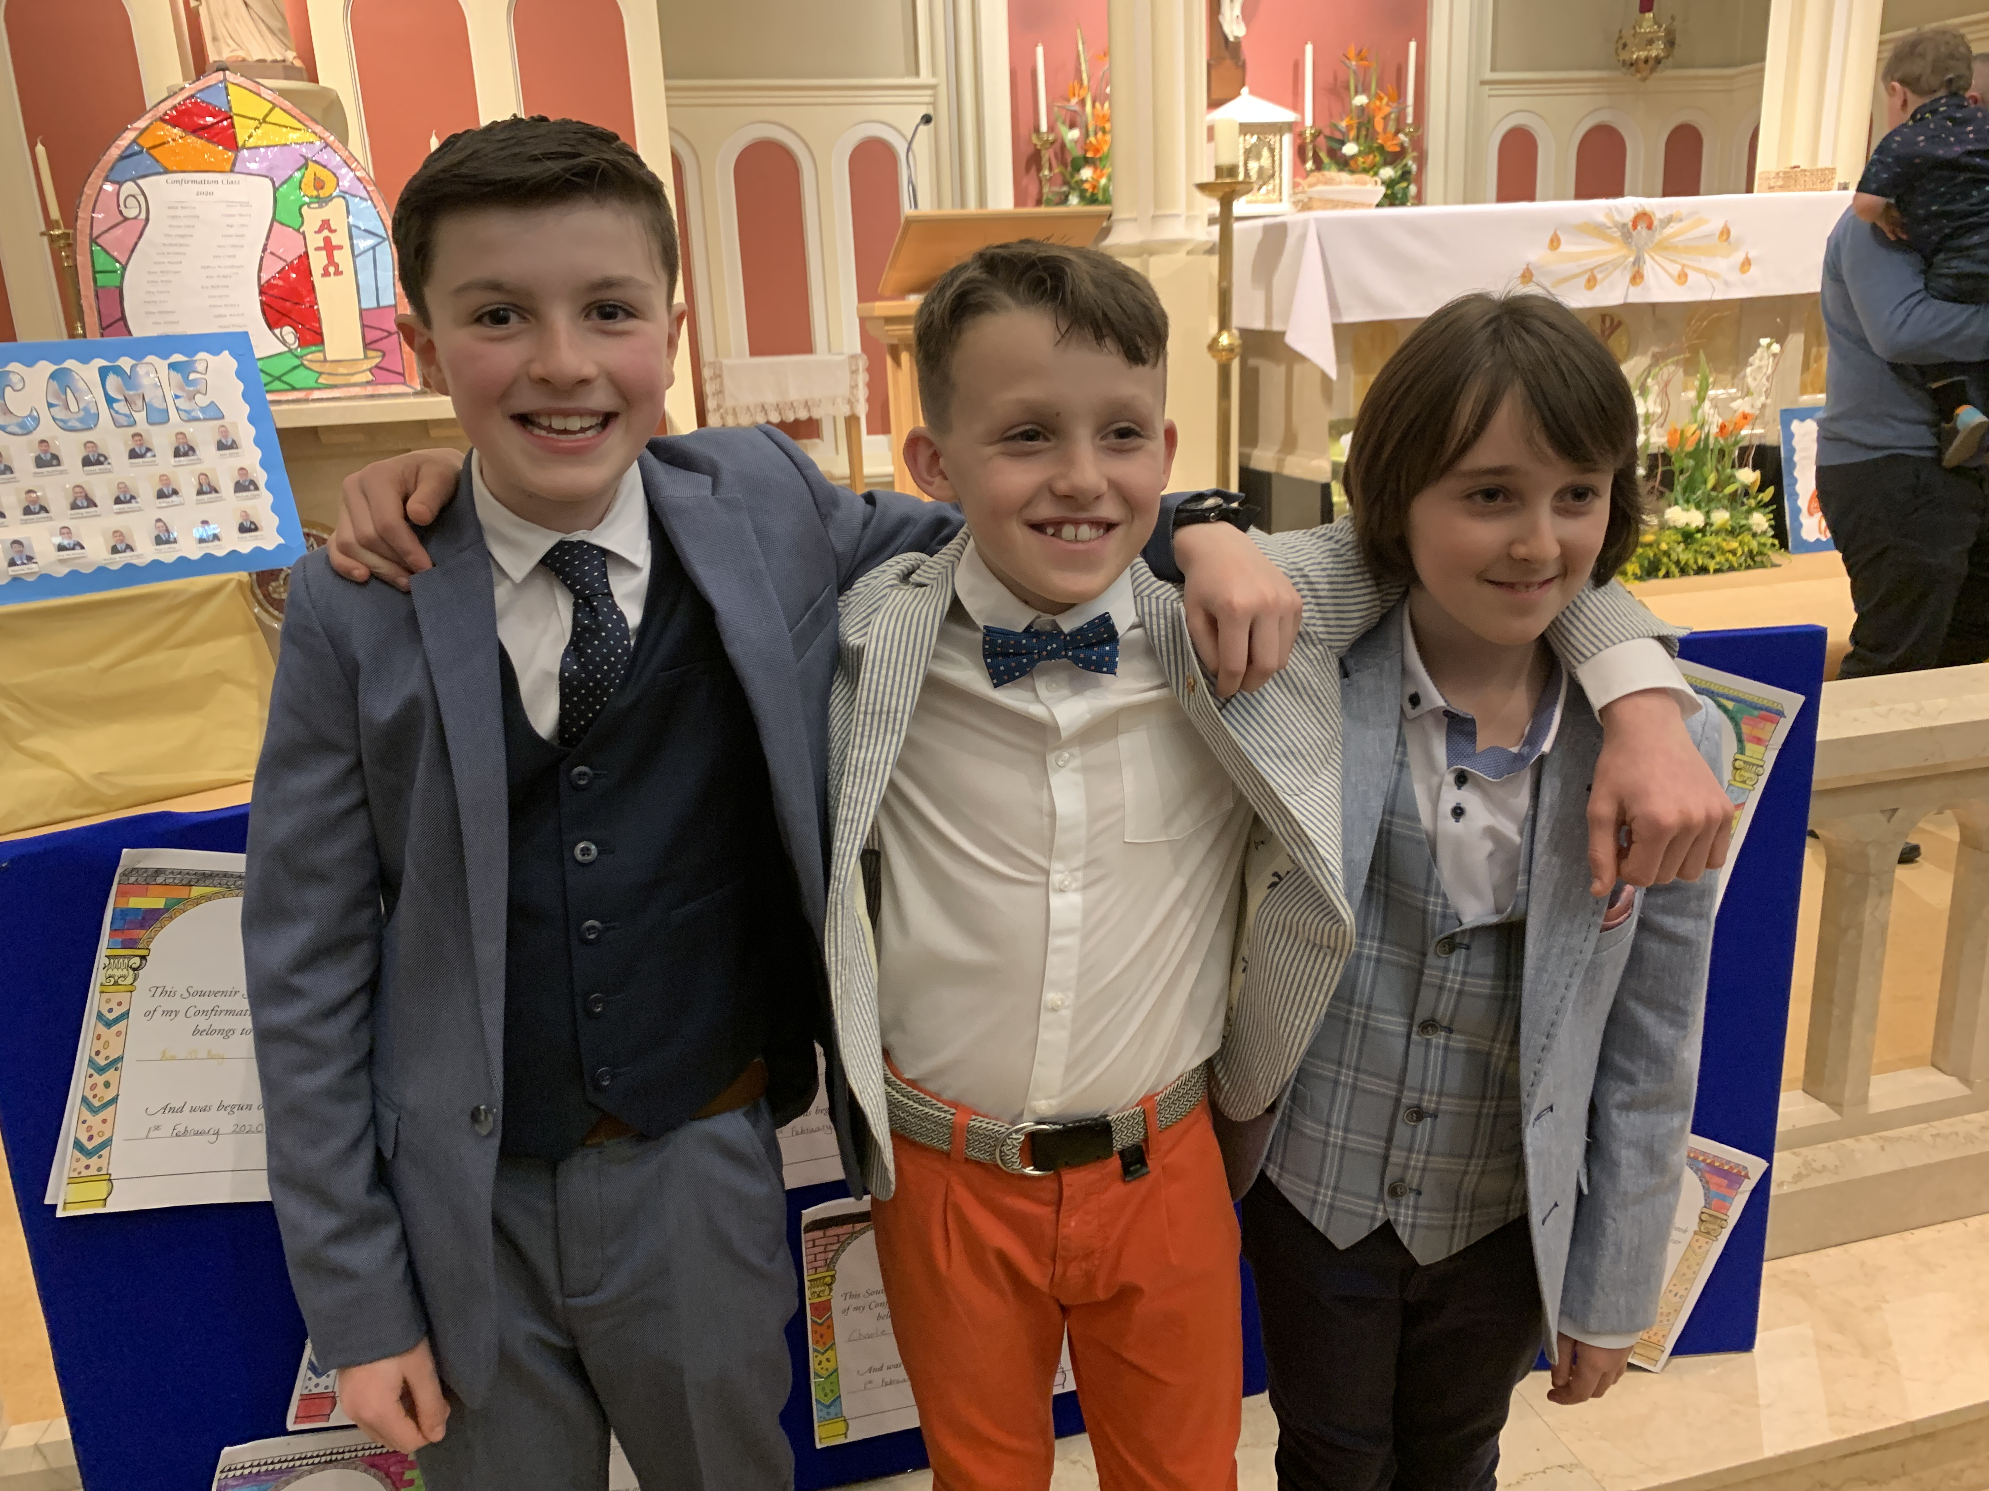

Football:
I was involved in an indoor five-a-side football tournament in Dungannon. We were really stunned with our performance and qualified for the finals in Cookstown. We celebrated with a trip to the shop.

School visit – the dangers of smoking:
I was fascinated with the information from a smoking prevention team. They informed us about the numerous chemicals in cigarettes and the dangers of vaping. I thought it was interesting how much money people could save if they didn’t smoke.

