Special P7 Memories

My favourite memory of primary 7 is when we played in the Tyrone football tournament in Dungannon. There were 8 schools competing but unfortunately even though we made it to the final, we were beaten by one point. It was a great day out, daddy came to watch me play and I had tons of fun with my friends.

My second favourite is my Confirmation day. We got out of school early, I got my nails and hair done especially. We had worked so hard to prepare for this Sacrament and the service was lovely. I sang and said a prayer during the service. Lots of my family were there to celebrate and afterwards we went to Viscounts restaurant. Some of my friends were there too.

It was hard to pick just three as I have had such a super year but another favourite is singing solo at the Christmas carol service. I was a wee bit nervous, lots of my family came. O Holy Night is my favourite Christmas carol and I loved singing it in the chapel.

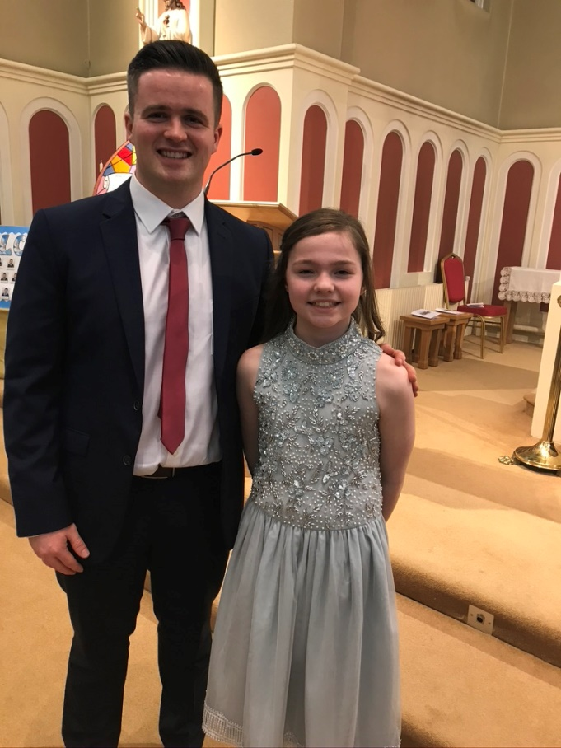
I have really enjoyed my seven years at St. Mary’s Cabragh. I have had so much fun, learned lots, made lifelong friends and I hope I will be as happy in my new school.

