Sinéad Traynor

Happy is me,
As I set down my sports day trophy,
Summer is here,
I feel so free!
Full is the beach,
With picnics and treats,
We get ice-cream each,
Try not to drop it please!
The weather is bright,
With children about,
But wait until night,
With all the twilight.
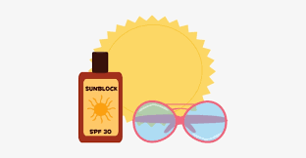
Playhouses are clean,
No spiders about,
But instead some sunscreen,
Ready to squirt out!

